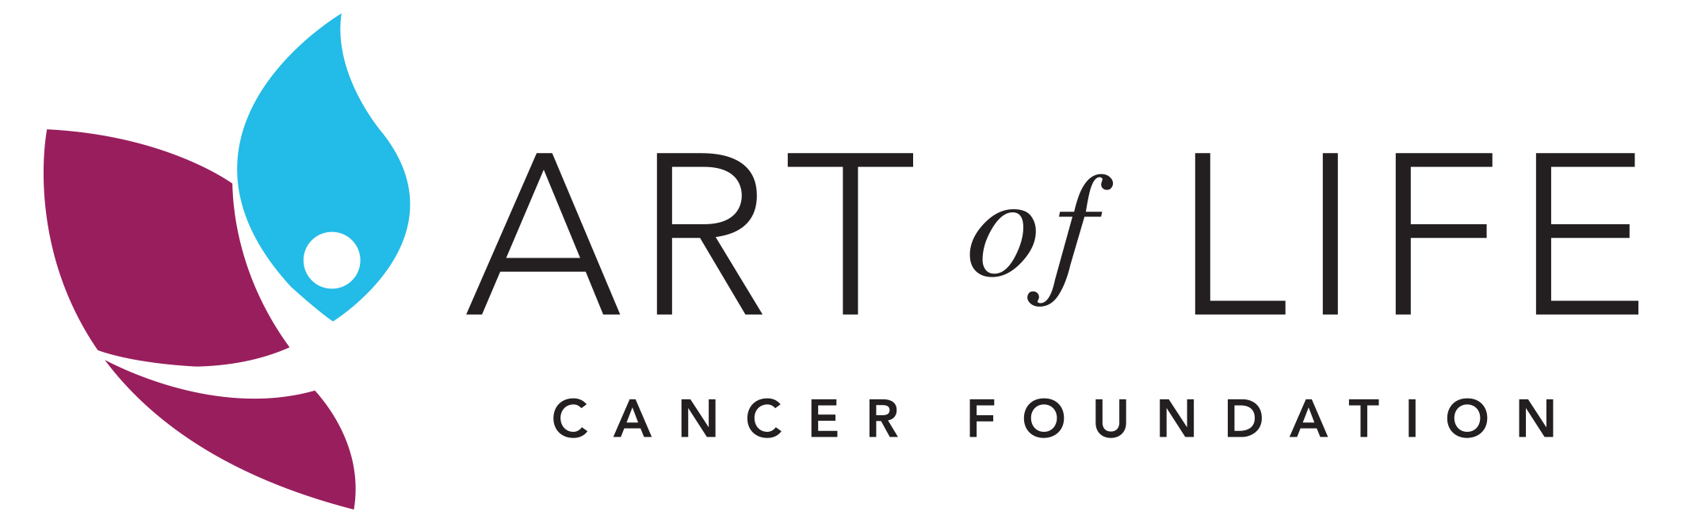

ARTISTIC DIRECTOR GUIDELINES

WHAT IS AN ARTISTIC DIRECTOR?
The Art of Life actively recruits Artists who are passionate about healing art and supporting others who have been impacted by cancer. An Artistic Director is patient and knowledgeable on providing art instruction and puts equal importance on the creative experience as well as the final outcome of the art.

REQUIREMENTS FOR NEW ARTISTIC DIRECTORS
- Meet one-on-one with an Art of Life team member
- Lead a minimum of 1 Art of Life Art Workshop prior to leading a group for the Paint it Forward project (past Artistic Directors have already met this requirement).
- Provide personal and/or professional references upon request

WHAT THE ARTISTIC DIRECTOR WILL RECEIVE
- A $200 honorarium per group for the commission of your design, oversight, and instruction of art on canvas that will bring hope in a unique way to cancer survivors in this community. Artistic Directors may choose to forgo the honorarium and donate their time and talent if desired.
- Name recognition on a plaque next to the displayed artwork (at various locations throughout the community) and on the back of commemorative art cards.
- Professional website exposure on the Art of Life website and/or social media

HOW THE PAINT IT FORWARD PROJECT WORKS
This project is a “once-in-a-lifetime-experience” for cancer survivors (anyone with a cancer diagnosis at any point in their life). Artistic Directors are linked with 3-4 cancer survivors to co-create a work of art that celebrates life and is inspired by a message of hope. The Paint it Forward experience is for the survivor, but the finished canvas is their gift to the community, sharing what they have learned as a result of cancer or a hopeful reminder to those who walk the journey after them. The Art of Life provides ongoing workshops to allow for individual expression, whereas this is a collaborative experience uniting survivors in one voice.

PURPOSE OF THE PAINT IT FORWARD PROJECT
- To bring attention to LIFE and the fact that more men, women and children are surviving cancer through early detection and treatment advances.
- To bring LIFE to medical offices throughout the Valley as well as the Art of Life Healing Garden in Woodward Park.

ART SPECIFICATIONS
- The group will work collectively on one gallery canvas – 24”x36” (may be hung horizontal or vertical)
- Acrylic, collage or mixed media may be used on the canvas (no oil paints or 3D elements may be used on the canvas).
- The color palette should be rich and colorful. Please avoid palettes that are soft, dull, dark or stark.
- The artwork is about LIFE, not about cancer, and will be created under the vision and direction of the Artistic Director. The goal is to focus on positive aspects of life, not negative. Admirers who see the canvas should feel inspired, uplifted, curious, amazed, or a host of other positive emotions.
- The interpretive subject of the piece can be inanimate or animate, and the style realistic or abstract.
- Please avoid the use or likeness of copyrighted images.
- Please paint the sides of the canvas as the work will be displayed unframed.
- Cancer survivors are encouraged to sign the BACK of the canvas, rather than the front

The step-by-step process:
- Apply. Application deadline is Monday, May 2nd, 2016. Twelve Artistic Directors will be selected for the 2016 Paint it Forward Project by Friday, May 6th, 2016.
- Inspiration. The Artistic Director will receive a list of inspired themes that were selected by participants in their assigned groups, so one can see the common points of view. This inspiration will help direct your proposal for an art piece.
- Proposal. With a limited amount of time to complete a piece with your group, we are commissioning the Artistic Director to design a concept for the art masterpiece and submit it to the Art of Life team for approval, two weeks prior to your event. Proposal would include:
- Art Medium (acrylic, mixed media, etc.)
- Techniques to allow up to 4 people to collaborate on 1 canvas
- Sample of finished piece
The Art of Life will provide feedback and has the right to request changes, in an effort to provide the best experience for the cancer survivor.
- Supplies. Thanks to the generosity of the Dyer Family Foundation, the 2016 Art Supplies, including the gallery canvas (24x36), acrylic paints and brushes will all be provided onsite at the Art of Life office. If additional materials are required for your medium, you will be responsible to provide these items.
- Paint it Forward – Night 1. The purpose of the first meeting is to “break the ice” and get to know those in your assigned group. Two other groups will be meeting in adjoining suites to offer an environment of camaraderie and support. The focus is not on cancer, but rather on LIFE. Give survivors in your group permission to be open with one another and share only what they are comfortable with. We encourage groups to begin your first layer of paint to allow it to dry overnight. Share design with group and allow them to embrace the project.
- Paint it Forward – Day 2.
  - Artist Involvement. The purpose of the Artistic Director is to offer instruction. We encourage you not to paint on the survivors’ canvas, but to demonstrate on a separate canvas or paper when necessary.
    - There will often be someone in the group that is less confident and puts their artistic abilities down. Encourage and empower them to be equally involved with everyone else.
  - Co-Creation Process. The Artistic Director is providing the framework of the project, but survivors should/can be encouraged to suggest their creativity within the guidelines the Artistic Director has presented. The canvas is a collaborative project however any creative liberties by individuals in the group should be run by the Artistic Director for approval.
  - Title & Written Summary. Each group will be asked to submit a Title for their art piece as well as a short paragraph that describes the theme, symbolism or story behind the art. Be sure to allow time to put their experience into words. This paragraph will be shared on the back of the commemorative art cards and will also be hung on a plaque next to the art piece.
- Unveiling. The culmination of the Art of Life Paint it Forward Project will be held within three months of the completed painting. It will be a special time to celebrate life and the participants will be eager to introduce you to their family and friends.
  - The original canvas will be showcased at various locations throughout the Central Valley.
  - A copy of the art piece will be a part of the display rotation at the Art of Life Healing Garden at Woodward Park
  - The original will eventually be auctioned to support yet another team
of cancer survivors to participate in the Art of Life’s Paint it Forward Project

WORKING WITH CANCER SURVIVORS
Here are a few helpful tips on working with cancer survivors:
- In Treatment or Out of Treatment. The participants in your group may be currently undergoing treatment or have been a cancer survivor for years. If they are undergoing treatment they may be tired or need to sit down. Just ask what would work best for them if it appears they are weak. Remember, this can be a long day for the survivors, so encourage them to take a break, walk around, eat a snack, or sit and rest. We want to make sure that they have a positive experience
- Privacy. Although participants will sign an agreement with a waiver, we want to be sensitive about their privacy and will ask them if they wish to remain anonymous. Please respect each person’s dignity and privacy by not asking about their cancer. It is only acceptable if they initiate sharing with you or the group.
- Photographs. We often have someone on-site to take photographs during your art production process. We will notify you if a member of your group wishes not to be identified or photographed.
- Emotions. Remember that cancer is an emotional experience. On the challenging side, you may encounter all kinds of emotions during your time with your group including expressions of sadness, anger, increased sensitivity, or melancholy. On the flip side, you may be surprised at how upbeat, full of life, fun and inspiring the men/women in your group will be…so just be prepared for anything!
- Your Role. The men/women in your group will appreciate your talent, creative guidance, vision, dependability, enthusiasm, commitment and care. We know you will make some great friends through this experience.
- Resource. Please do not hesitate to contact the Art of Life team at 559.301.5606 if you have any questions, challenges or need advice.

